**Games Design Document**

**Working Title**

**Genre:**

In terms of gameplay genres, the game will be a Third Person Shooter where the character model will take up approximately a quarter of the screen, zooming in a small bit whilst aiming and shooting at an enemy. When unarmed the camera will zoom out and give greater control over the camera to view the surrounding area.

The game will take on Science Fiction aesthetics, taking place in a futuristic setting. However, the game draws elements from the Fantasy Genre, specifically Magic, mixing both the Technology and Magic elements to create choices in how you go around different obstacles.

Because of the mixture of Sci-fi and Fantasy, the game will take elements from Shooters and RPGs. The player being able to customise weaponry with tech and magic, for different effects on different enemies as well as classes and magic types. The game will also have a semi-linear the player can go through, with different hub areas.

**Audience:**

The game will be aimed PC and Home Consoles, leaning towards hardcore playerbases rather than the people who are casual gamers, as phones started getting quicker and easier games for people to play on the fly, the casual audience has moved to mobile gaming. Putting the game on PC and Consoles will allow greater freedom in the quality of texturing and other graphics settings as well as having controls that fit keyboard/mice and controllers, so that controls aren’t clunky on a small screen.

The intended PEGI rating is 16, this is so we can keep mature tones whilst keeping the game open to a wider audience. This means we won’t be able to show much blood when the game goes on or any explicit scenes, but we will still be able to show violence towards characters, being able to have a more complex plot as the older audience will be able to understand better than younger audiences.

**Purpose:**

In this RPG, the player will explore an advanced universe that mixes Technology and Magic, the game will explore what a universe would be like if they supplemented power sources and the need for bulky technology to make certain types of weaponry and machinery work, in what state would the universe be and how would it be explored, what would society be like? How would people live? Where does Mana even come from? What sort of issues would be brought up?

**Core Mechanics:**

Movement in gunfights will focus on running and sprinting around the world. The player defaults to running, pressing and holding down Shift/Left Analogue Stick to sprint. To crouch in these fights, the player will have to press and hold down Control/Right Analogue Stick, the character will automatically crouch next to objects when close to them, to take cover. Jumping on top of objects will be performed by pressing the Jump Button, but the player will not be able to jump when not next to an object, this will also be used to get over objects if they’re small enough.

When outside of gun fights, or in the HUB Locations, the player will be less restricted in their movement such as being allowed to jump when away from an object as well a button to slow down their movements to be careful of their surroundings.

Shooting a Weapon takes up ammo, as well as Mana if the weapon uses any Magical Enhancements. There are different types of weaponry, such as Pistols, Shotguns, Assault Rifles and Sniper Rifles, being similar to their real life counterparts although they are much more futuristic in terms of design and can accommodate magical enhancements giving the technology and ammo different behaviours depending on the type of magic.

There are other types of technology that can be used in combat, these often heavily rely on Magic and can help in combat, such as healing, boosting different magic as well as hinder the enemies abilities. They can be tied to you and other party members, used as a spray, mines etc. both sides can use them within each maps.

Weapons use up ammo and mana. Depending on the type of gun and the magic being implemented onto it, the technology level of the clip, and how powerful the magic is. Mana will be used even when there is no magic implemented onto the gun (so that bullet can be fired out of the gun without using the moving parts of the gun), however this will be at an incredibly small rate as to not affect gunfights. When more and more magic abilities are placed onto the ammo and the gun itself the more mana is used up, making the player strategically decide how they are going to use up mana and how they might be able to recharge.

Like most guns, ammo is used in clips, they can be stored in one’s inventory and picked up on the battlefield to be used in the various types of weapons (different pieces of ammo are put into different types of guns) mana for technology is built up over time, much like how it is when used on its own, it can be instantly recharged at stations or by using canisters of mana. If mana is completely depleted from the gun, then it won’t recharge on its own, it will then have to manually be recharged.

All 3 bars indicate how close the player is to dying in game, the Health bar is at the bottom as that is the last line of defence (represented with a simple bar), the armour in the middle (signifying how damaged the armour is) (durability is represented by a tessellation of shapes in a bar) a and the barrier on top (being magic and represented by multiple lines representing hits before the barrier is down). The Barrier is the weakest of the 3, while protecting the armour underneath, it doesn’t take as many hits as the armour, and so it will be down first in a gunfight if the player isn’t careful, although, depending on the amount of mana the player has, it will go back up after a certain amount of time. Armour will get damaged as it gets shot at, and it cannot be recovered for the rest of the mission, meaning the player will have to rely on the Barrier and the Health. The next mission the player plays, the armour will be back to 100 percent. When the player gets down to health, they will have to recover it using health stations and packs within the level.

There are multiple classes within the game that changes how the game is played and how the character works. Overall there are 8 Classes that go across both Technology and Magic, which can branch out into different subclasses depending on the actions of the player. These classes will allow different magic abilities, weaponry and technology to be used by the player, as well as other party members.

The game allows to configure technology and magic, creating different effects on ammo and technology. These different effects will affect the enemies they face, as they also have different classes, having weaknesses and strengths against different types of ammo (similar to how the player’s class system works). The effects on the ammo will work based on their type and have multiple levels of usage, whilst base levels will have basic effects, like setting an enemy on fire, or freezing them, higher levels will have more complex effects, such as ice explosions.

Other than weaponry, there are other types of technology that can be switched out to give an advantage in gunfights, such as healing as extra barriers to aid players, coming in different variations, such as sprays, lines of fire and latch-on magic to boost health or barriers, droppables to effect the surrounding area (such as the previously mentioned pieces of technology) and can act as places to hide under or traps to snare enemies in gun fights through various methods depending on the type of magic being used.

Enemies have different types, that get tougher to fight depending on what they are, and as the story goes on. These types are also split. Technology itself, being much bulkier and easy to hit as they don’t use magic to slimline their weaponry, being easy to hit but having more armour than the rest of the enemies, dealing more damage to the player. Magic itself, having no armour but having more barriers and magical abilities, smaller in comparison to technology users. And those who experiment with mixtures, being similar to the player in ability spanning across the player class system, with different technological and weaponry abilities.

Aside from the choices that player makes when picking class, weaponry, technology, magic, and how to use them with upgrades, they can make choices in dialogue and gunfights/missions that can put the player down certain paths of the story, meeting different characters, or leaving them behind for various reasons, eventually leading onto different endings depending on what they do. These choices can be in dialogue choices, or can be moral dilemma segments, these segments will take the player down the different routes of the story, while dialogue choices and gunfights will decide what choices you get to decide in the Moral Dilemmas. These will be introduced after the tutorial segment to let the player get used to the games mechanics as well as introduce them to the universe they will be partaking in.

**User Interface:**

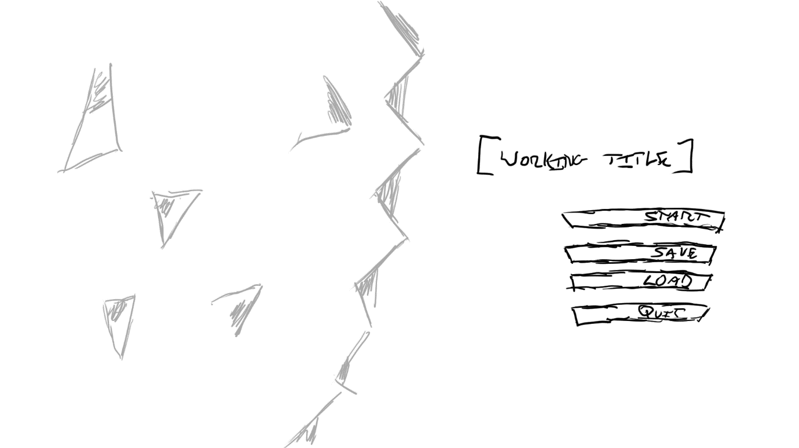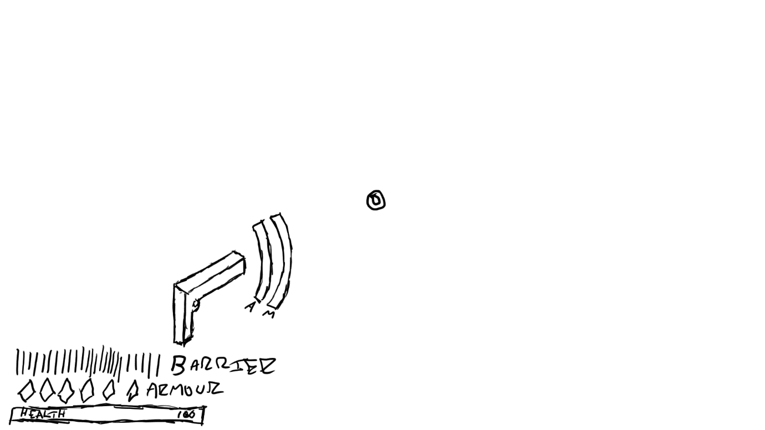

Much of the UI will take up the bottom part of the screen to not distract from the rest of the screen and what the player might be shooting at (in which case there will be a suitable reticle for each type of weaponry, for example Pistols would have a smaller reticle than a shotgun reticle, which would be much larger to fit the shooting style). Ammo and Mana count would revolve around the gun that the character is holding, making it easier for someone to check how much ammo and mana they have without taking focus off what they’re doing. Health, Armour are displayed at the bottom left of the screen, Health is placed at the very bottom while armour and barriers are above it.

Much like the UI for the game itself, it will be minimalistic. Much of the menus will have a clouded and shattered glass effect, blurring out the activity behind it. Depending on the player, they can have the menu in a light theme or dark theme. The words will stand out from the screen, making it easy for the player to read and work with.

**Scale Plans:**

**A close up of a map

Description generated with high confidence**

The tutorial will take place in a previously mined asteroid, the player will have to go in and find something that was left there by the company that was mining the asteroid, there are multiple factions there fighting for the item, either to protect it or obtain it, giving the player a first good luck at the factions in the game and how the mixture of Technology and Magic works, what types of enemies the player will be facing and an introduction to the characters.

**Placement of Gameplay Elements:**

It has multiple areas where people can shoot in an open environment as well as corridors in between to fight in. This is to give players situations and diverse types of enemies to work around, like they will be doing in the game later. The tutorial is easier than the rest of the game, but the different types of enemies will get tougher and have more abilities when time goes on.

While the more open areas will feature factions fighting each other, as well as you, giving the sense of some of the small-scale battles you will come across in the game, whereas the corridors will give you a sense of the factions on their own.

3 of the rooms will have a sort of mini puzzle to open the next room, and there’s one that includes two rooms, to progress through the level, these will mostly consist of technological puzzles but also have magical elements to introduce the player to how the game and missions will work.

In Area 1, the puzzle was collecting objects and finding out how the pieces fit together (in order for the key to work correctly) and how they will be able to fit into the door, a simple puzzle which will eventually have harder variants throughout the game. In Area 4, the box needs to be hacked to be opened, and allow the player to open the door later in the puzzle. In Area 6 there is a similar puzzle, but it involves files stored on the computer, both to find out about the location the player is in, as well as to mess with the door files, to let it open for the characters.

Ammo and Mana are dropped by enemies and can be instantly refilled (if the player is running low) through the boxes. While there are more boxes at the start, there become less and less boxes that contains ammo, eventually just becoming a singular box containing both ammo and mana.

There are multiple types of enemies, getting harder and multiplying throughout the level, these enemies will be fighting each other (depending on the faction the enemy is in) and if they notice you, at least 2 will direct their attention to you, the others will try and avoid you whilst fighting the opposing side.

There are many boxes and cover areas for the player to cover and try and shoot towards the enemies, with the later covers having the players claim them as they’re taken by different enemies. This will help the player stay alive when fighting against enemies, reducing the amount of damage taken to the barriers, armour and health.

**Design of Goals, Challenges and Rewards to fit with the chosen audience and genre:**

The goals of this tutorial level include getting to the end of the level, to progress through the story and levelling up abilities, so that the player can get better equipment and newer abilities, with challenges being the enemies throughout the level as well as puzzles that the player will encounter throughout the duration of the level. These will result in XP and materials, while XP will help you gain abilities and new equipment, upgrades will need both XP and materials. The player may also get new weapons to pick up and money, to buy products at stores when the player is at a HUB area. All four of these rewards will be available as pickups from enemies and rewards for completing the mission.

These sort of missions are usually part of RPG games, usually allowing the player to use XP to level up themselves and their abilities as well as getting new abilities, which will mean it will appeal to people who like these sort of genres, and are interested in the development of these items.

**Design of Progression to fit with the chosen audience and genre:**

Like many RPGs, NPCs will be one of the driving force of progression. As mentioned previously, they will be part of dialogue choices advancing the story (through giving them missions and story quests) as well as some moral dilemmas taking the player down routes of the game. They will also be used as party members in your team, to help you in gunfights and missions, whether to help take down enemies or heal each other. These party members will be main characters within the story, NPCs the player will be spending the most time with.

The game will have a levelling system, giving the player more powerful abilities, the game won’t use a crafting system for this, opting for more as time goes on using a different skill, they will be able to upgrade that skill to get better abilities and technology/equipment. XP will be of primary use when it comes to levelling, which will be gained when killing enemies and completing puzzles and missions. Some abilities will need materials, of which there are four of them and you can only use them to upgrade pre-existing materials, as to not make it a crafting system that will over complicate the entire system for the player.

**The Folder Structure:**

The assets are put into 6 different main categories,

* 3D Models

3D Models are separated into Ammo (which is then separated into Pickups and Bullets, which will be separated into the types of guns as well using the gun name before the ammo), Mana bottles, Boxes, Environment of the Mined Asteroid (consisting of the rocks and architecture), Environmental Technology (which would be the built up areas), Secondary Technology which is separated into the types of Secondary Technology (Barriers, Deployables, and Healing) and Weaponry which is separated into the types that are found in game).

* Animations

Animations have been separated into the Player, Technology Enemies (Enemies that use more technology than Magic) and Magic Enemies (Enemies that use more magical elements than technology). This is so I can tell which animation is tied to who if used, as the player and different types of enemies will have different animations to each other if used.

* Player Model & Enemies

While the player model is placed in the surface folder, the two enemy types from Animations (Technology and Magic), this is so I can easily distinguish what type of model the enemy and player is, in which the enemies will be named in these folders.

* Particles

For the tutorial, the folder has subfolders called Fire and Ice, as they are the main two types of Magic the player will be using.

* Textures

The Subfolders consist of Asteroid (which refers to the rocky areas the player will be in when in the tutorial level) and Held-up Areas (which basically means that these are the built areas that the player will be standing on, which will be flat.)

* UI

The UI is divided into each aspect of the onscreen UI, the main and pause menu (which is put into Menu), Ammo, Mana (both Ammo and Mana being next to the gun ingame), Armour, Barrier and Health (being at the bottom left of the screen) and Reticle (which is in the middle of the screen helping the player aim), these are separated so I know what part of the UI the files are a part of, so there isn’t much confusion when I go to place it all together, as some assets might be similar and could get confused (such as Ammo and Mana). However much of the UI has been made to be distinct between each other (such as the Health Bar, Armour Tessellation and Barrier Lines).

**File Formats: \***

Many of the assets will need to be uassets so we can use them in engine, if I want to edit them (or to open them in 3DS Max) they will need to be FBX files. Much of the Textures used will be png files to reduce the loss in quality, and although it might not compress as much, the files wont be used on a mobile phone, being more on consoles and PC meaning the game will be able to load higher resolution assets as there’s not a technological limit (at least, not as much as mobile devices).

As for audio file formats, I am going to use the .wav format, as it can give higher quality audio, while the .wav formats still compress files, it can still give the player good audio, .wav files becoming large at points, which is ok when the game is being installed on a PC or console, these sound formats would not be good on a Mobile device, much like .png formats. It’s also the recommended audio file type for the Unreal Engine.

I’ve chosen to use these file formats as they are compatible with the software I am using, namely 3DS Max and Unreal Engine, this is so that I can modify the files and import them for use in the software, creating the areas that the player will be going through, when playing the game.

**Naming Conventions: \***

Much of the Naming conventions are separated into the environment, technology, magic and fantasy depending on the type of asset it is. Many of the particles used ingame will be apart of magic folders, as much of the particles are used to display that magic is in game. For the tutorial the environment will be put into two categories, the asteroid itself being the rocks and other objects that are apart of it, and areas that are built, being technological and flat surfaces. Weaponry and other pieces of technology used will be named after the names they have ingame, and environmental elements will have asteroid_ for the rock types, norse_ for some of the architectural areas that appear or tech_ for the built areas the player will fight on when playing the game.

**Log of Assets:**

The Asset Log can be found on a excel spreadsheet given with the rest of the brief and consists of the Asset name, File Name, File Type, Asset Type, Resolution (for if it’s a PNG), Source, Copyright Holder, Permissions, Date Sourced/Created, Price and File Path (which will be using the P Drive, where the main folder is located). These headers are meant to give a precise understanding on what type of asset the asset is, and how its meant to be used based on the copyright holder and permissions, so that if it’s been sourced from outside, we minimise the possibility of getting sued.

**Copyright Holders and Permissions:**

Copyright Holders and Permissions are stated within the excel spreadsheet. These are here so we can trace back where the assets came from, (for example the Infinity Blade game which assets were released for free, or off the internet where people create textures and sounds) and so we can ask for permission to use them. Often by crediting the source in game.

**Suitability for the Audience and Purpose:**

Much of these assets I have chosen fall within the Sci-fi and Fantasy Genres (with much of the environment being Sci-fi and the Particle Effects being Fantasy) helping the game explore how magic and technology would be combined. How the weaponry would work alongside magical enhancements.

The assets I have chosen are semi realistic, but still have a stylistic feel to them to give that sci-fi/fantasy feel, while still drawing in older players (as we are aiming for 16 and older), people who both want games to be realistic as well as others who might want the stylistic aspects to stand out.

**Factors that have affected my asset choice: \***

As I am working to put the game on PC and Console, File Size can be big, although it’s preferable that it isn’t too big so that it doesn’t congest the PC and Console too much, so I chose assets that were high quality but not too huge that it takes up most space on the PC. This is the same reason I have chose .png files for texturing and .wav files for audio, while they are high quality, they still have some compression so they don’t take up a lot of space. As for .fbx and uasset, these were chosen so they can be compatible with the Unreal Engine and 3DS Max.

As for size of graphics, most pcs and consoles run at 1080p or 4K, and while 4K is in demand, I’m leaning more towards 1080p quality to reach a broader audience, although this is something that I can mess around with to appeal to 4K users. As for aesthetics, I chose assets that kept to this realistic but stylistic, to keep to the style of game I would like to have.

As for Availability, I chose assets that were free of use, and only needed crediting if I use it, this is because I do not have any money at this point in time and can only really use assets that are royalty free, meaning I can only use these sort of assets for the tutorial.

**Modifications to Files:**

For any modifications to 3D files, it would be for exporting them to different file types, for example from .fbx to uasset and vice-versa in order to edit the 3D model and then put it back into the Unreal Engine. This will also be for the Size, say a image or audio is a large file (and possibly a different file type) I can also export the file as a different type, compressing it and thus reducing the size and keeping it to Unreal Engine preferred file type. As for resolution, any texture is kept to 1080p, so it’s the primary resolution I would look for, modification to these files will include the upscale to 4K if it’s used.